I Know the parts of a

Computer!

C:\Program Files\Microsoft Office\MEDIA\CAGCAT10\j0285750.wmf

Name______________

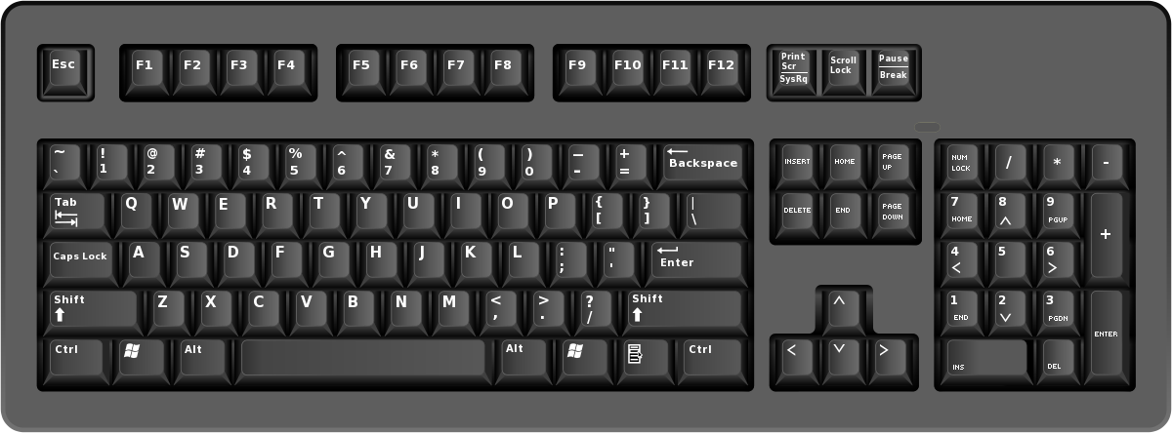

This is a ____________.

Keyboard



This is a ____________.

Mouse

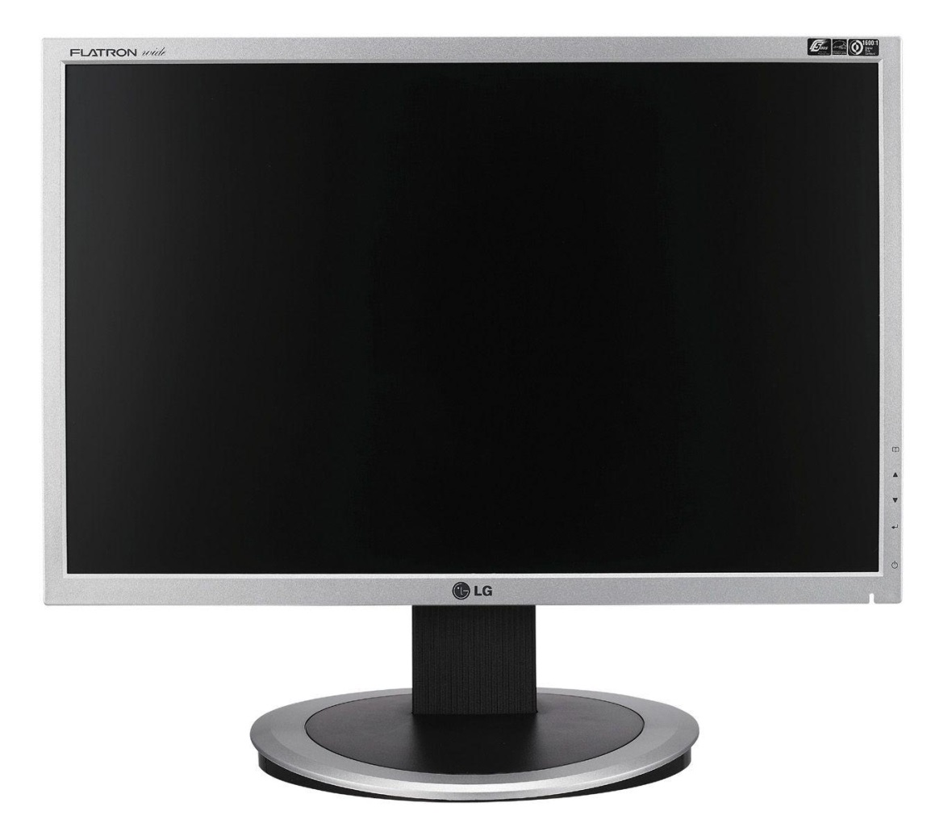

This is a ____________.

Monitor

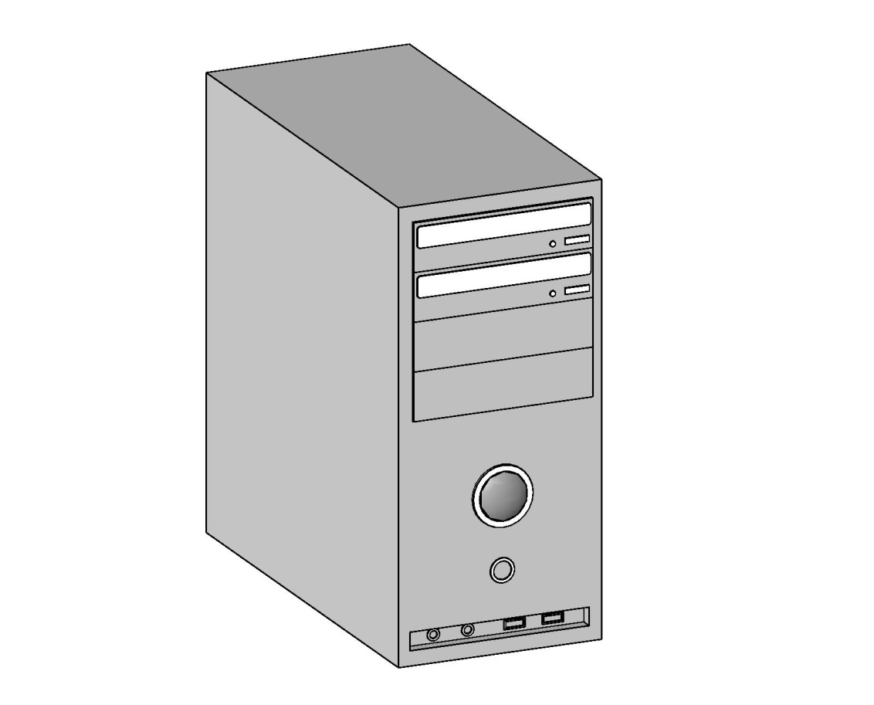

This is the __________.

System