«home_room»
«firstName» «lastName»
Dear Parents,
Your child has begun using the computer lab at school. All students are required to learn their Username and Password to log onto the school computers and other programs. On the other side you will find a sheet with your student’s information and a practice keyboard on it. Please help your student practice “typing” in both their Username and Password.
One suggestion is to post this sheet in a common area, such as a stairwell or doorway. Each time your child walks past, they can “type” in their “secret code” before they can pass.
Helping your child to learn to quickly type their Username and Password will allow us to focus on using the computers to enhance your child’s learning.
Thank you for your support,
Mrs. Ruppert, Librarian

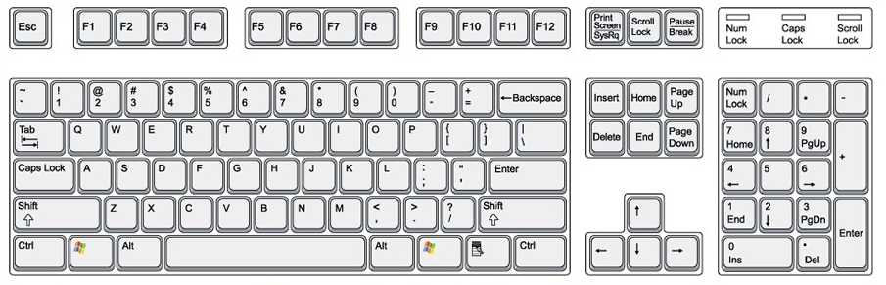
Username
«Login»
Password
«Password»

